**Exercise 1 : GIT-HOL**

# Step 1: Setup Git Configuration

1. Open Git Bash and check if Git is installed:  
 Command: git –version

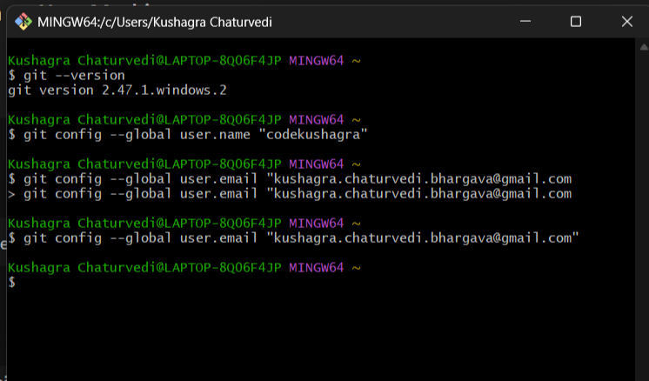  
  
2. Configure Git with your username and email:  
 Command: git config --global user.name "codekushagra"  
 Command: git config --global user.email [kushagra.chaturvedi.bhargava@gmail.com](mailto:kushagra.chaturvedi.bhargava@gmail.com)



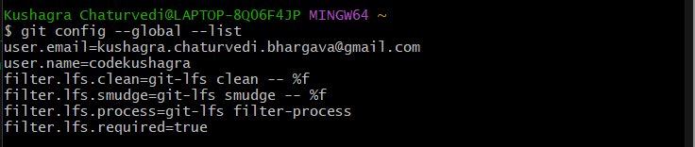  
  
3. Verify the configuration:  
 Command: git config --global –list

# Step 2: Set Notepad as Git Default Editor

1. In Git Bash, set Notepad as the default editor:  
 Command: git config --global core.editor "notepad"

  
2. Test if it's set correctly:  
 Command: git config --global –edit

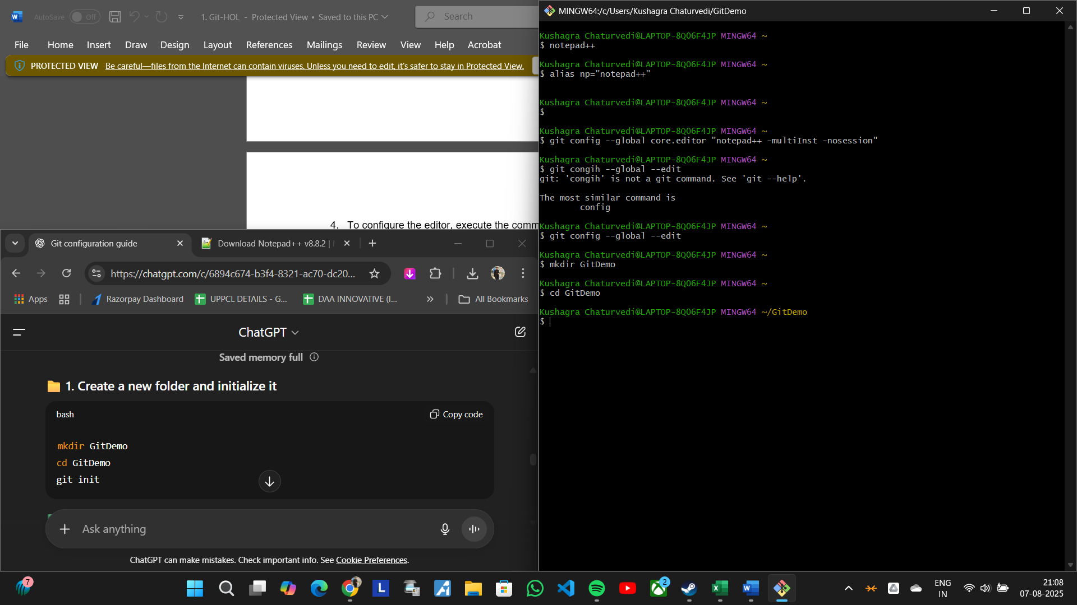

# Step 3: Create Local Git Repository

1. Create a project folder and initialize Git:  
 Command: mkdir GitDemo  
 Command: cd GitDemo  
 Command: git init

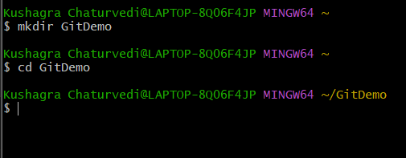

2. Verify Git initialization:  
 Command: ls -a  
  
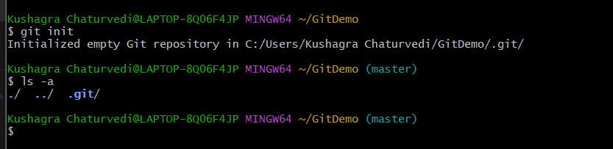

# Step 4: Create and Add a File

1. Create a file named welcome.txt:  
 Command: echo "Welcome to Git Hands-on Lab!" > welcome.txt

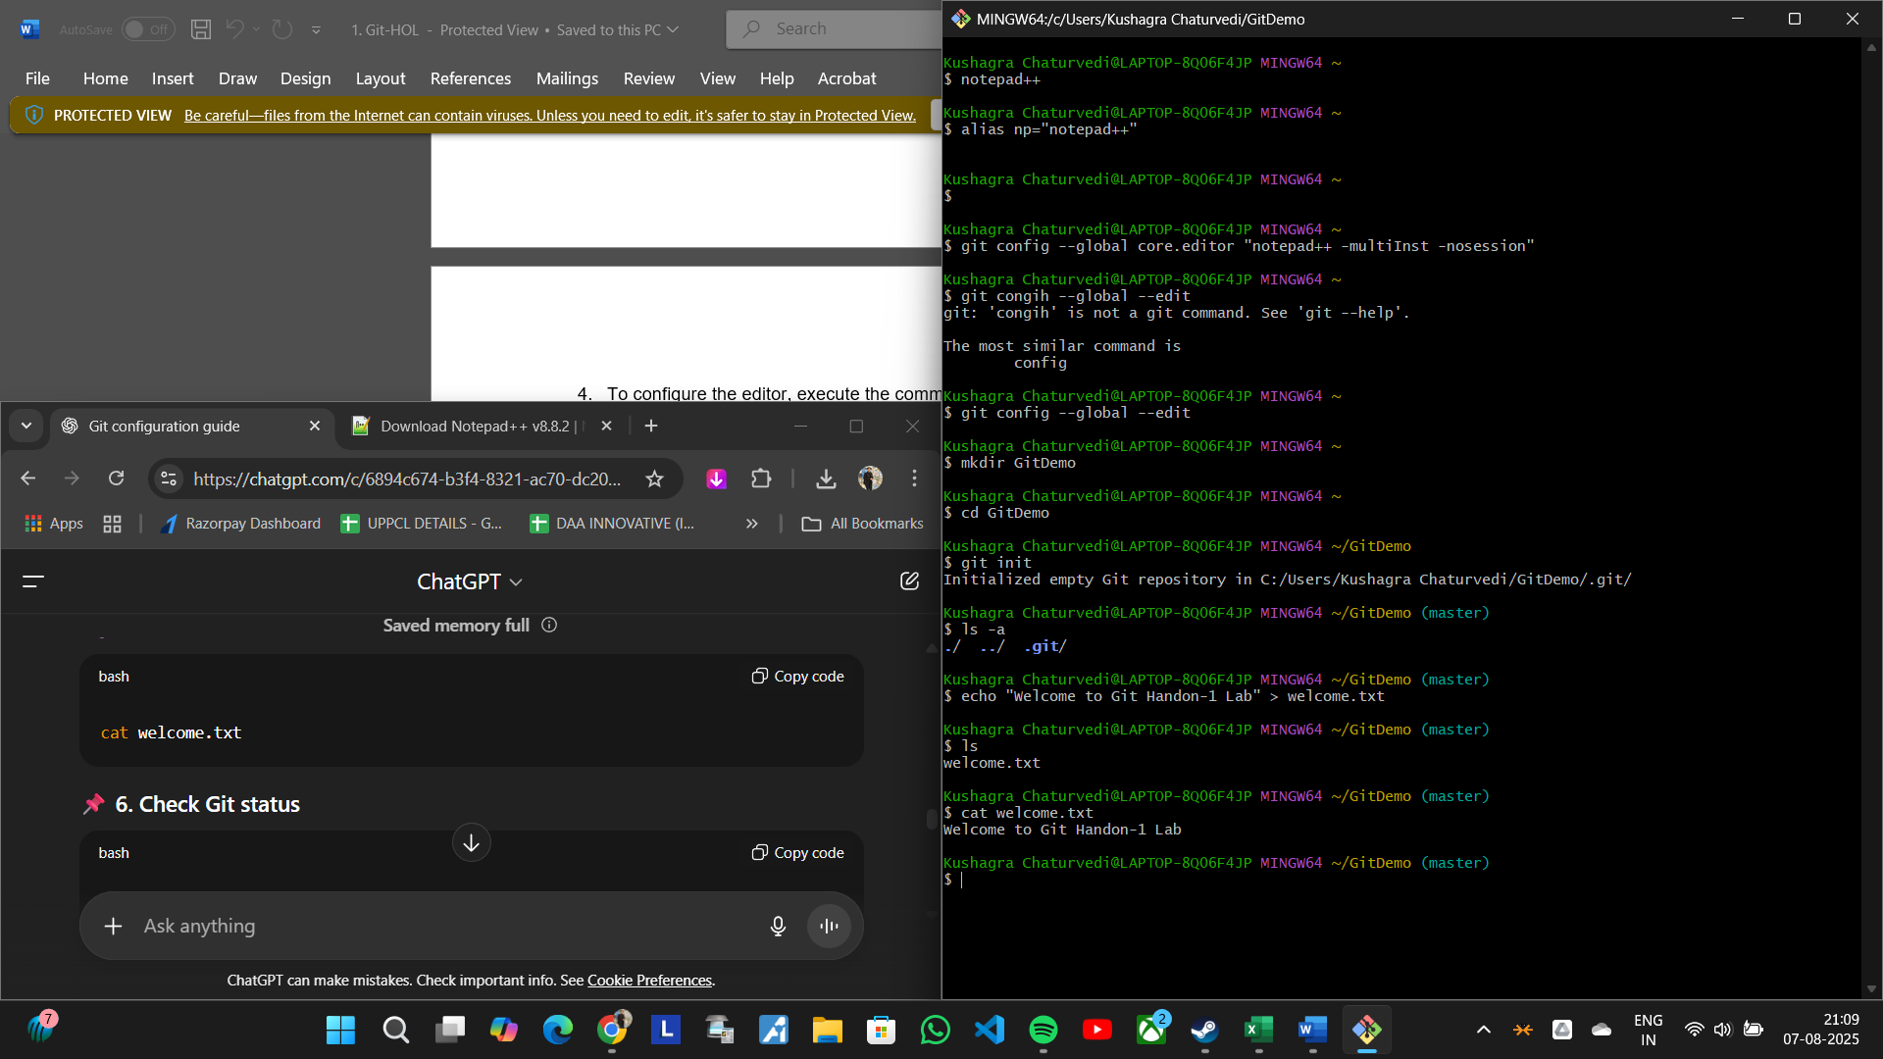  
  
2. Verify file creation:  
 Command: ls  
 Command: cat welcome.txt



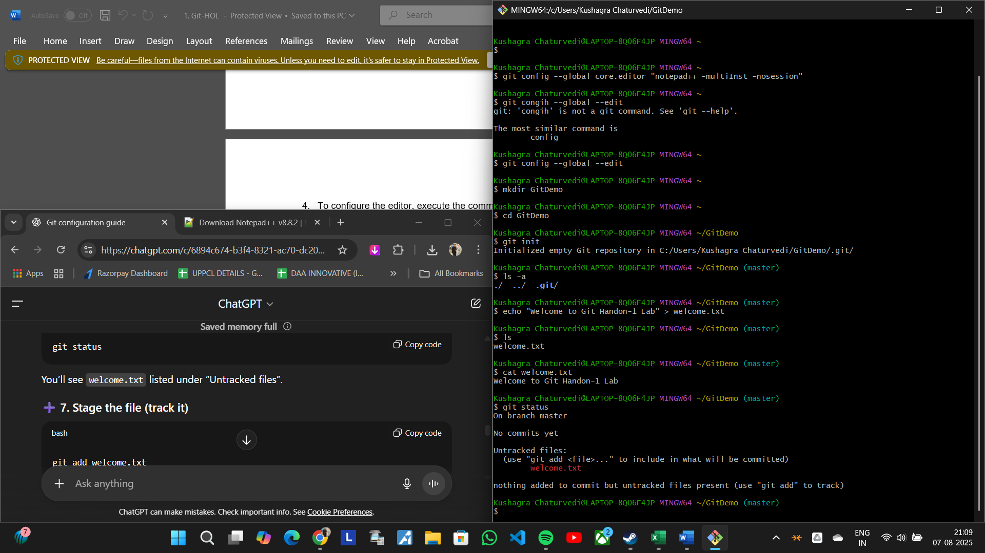3. Check Git status:  
 Command: git status

4. Stage the file:  
 Command: git add welcome.txt

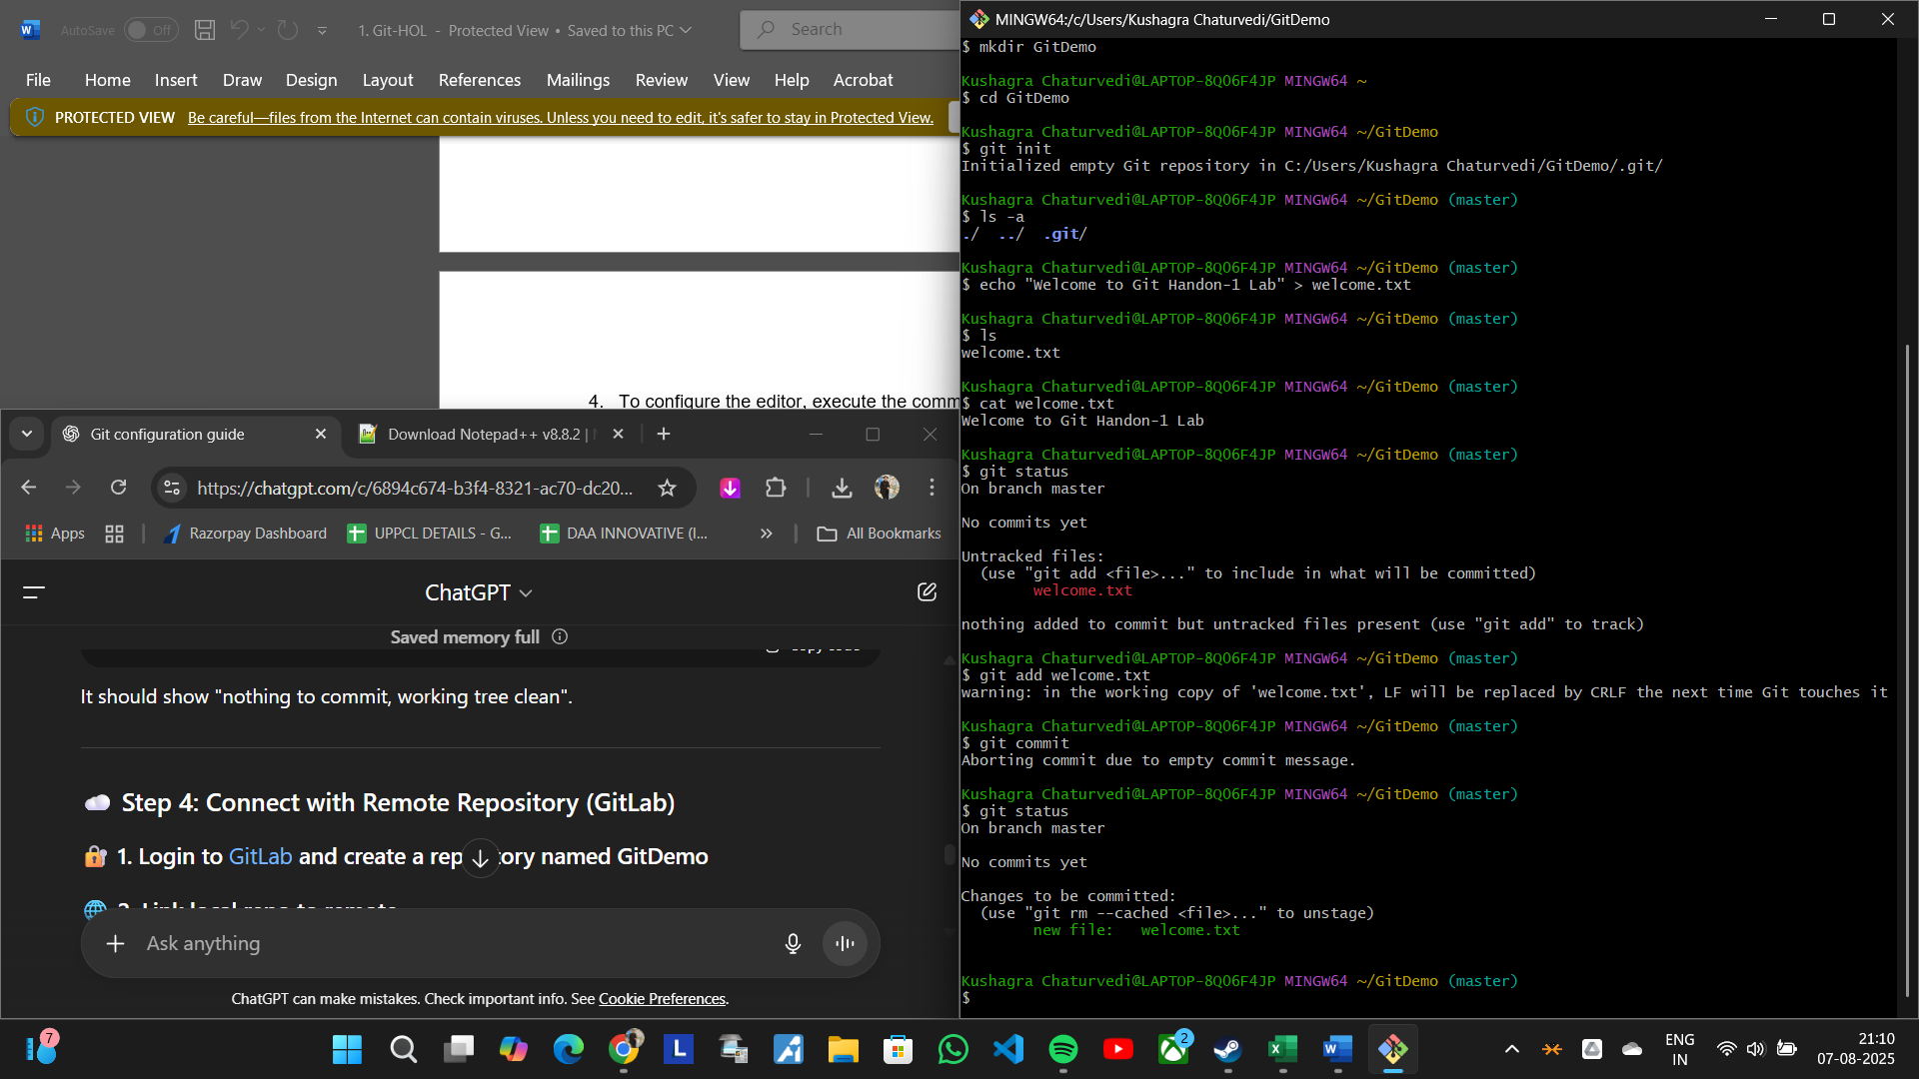  
  
5. Commit the file:  
 Command: git commit  
 (Write commit message in Notepad, save and close)

  
  
6. Check status again:  
 Command: git status  
  


# Step 5: Connect to Remote Repository (GitLab)

1. Login to GitLab and create a new project named GitDemo.  
  
2. Link the remote repository:  
 Command: git remote add origin <https://gitlab.com/codekushagra/GitDemo.git>

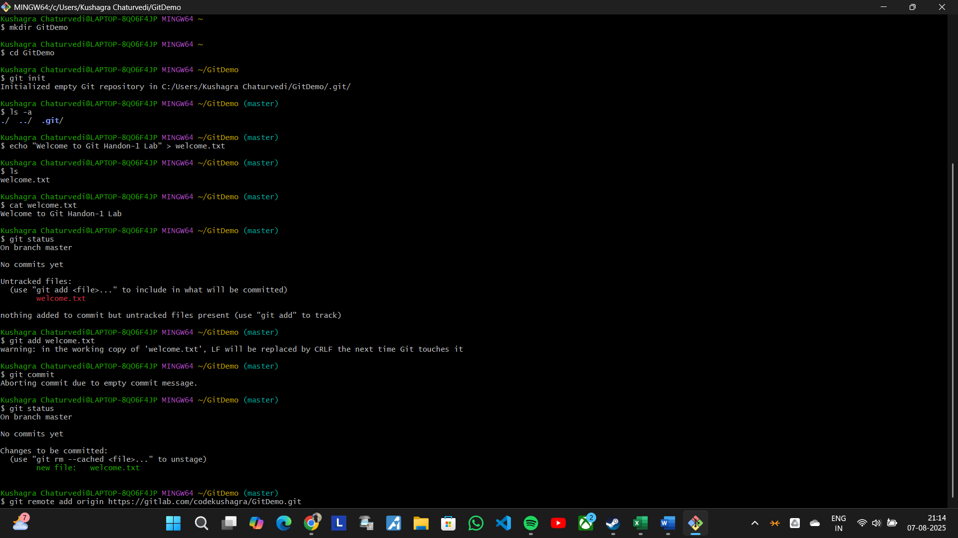

4. Push your local commit:  
 Command: git push -u origin master

